Date:
2 points for = 1 Reminder
1 point for =2 Reminders
0 points for = 3 or more reminders
Needs 34 points to get a reward (70%).
Rewards:

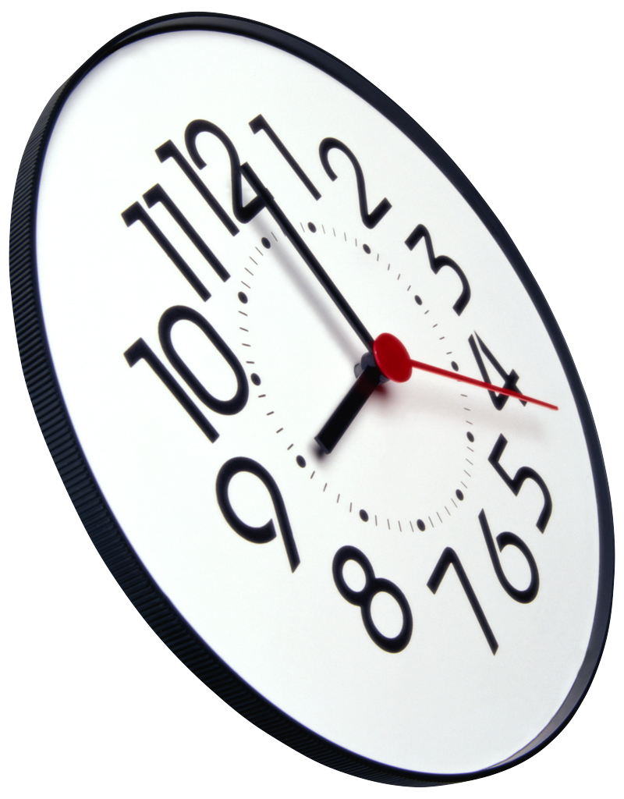  Time or  Activity | Complete the item on my schedule | Clean up after myself?
 |    |   
 |    |   
 |    |   
 |    |   
 |    |   
 |    |   
 |    |   
 |    |   
 |    |   
 |    |   
 |    |   
 |    |   
 |    |   
 |    |   
 |    |   
 |    |   

